1. **Agenda**:
   1. Enable Kafka Transaction in a MS that acts as a Producer.
2. 
3. 
4. 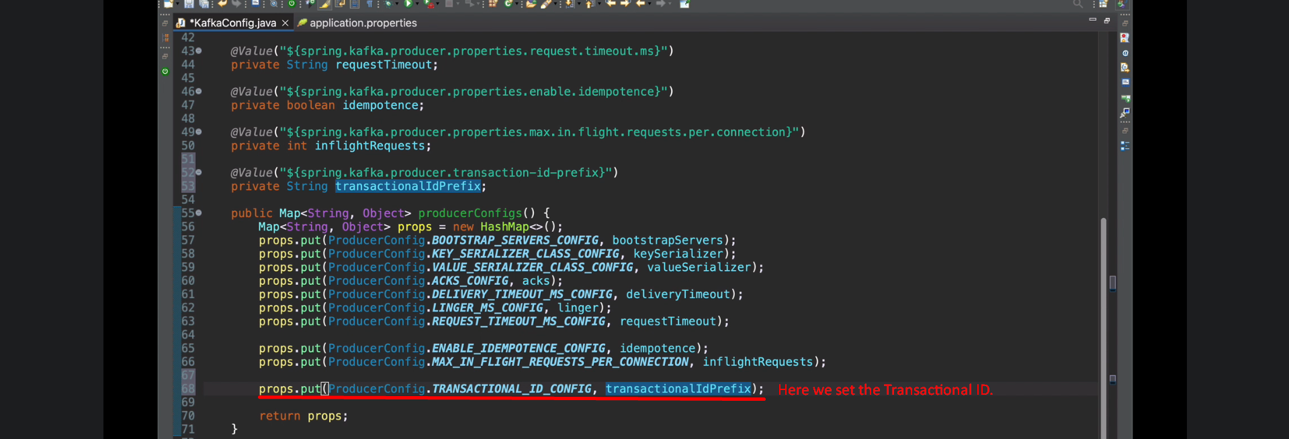
5. 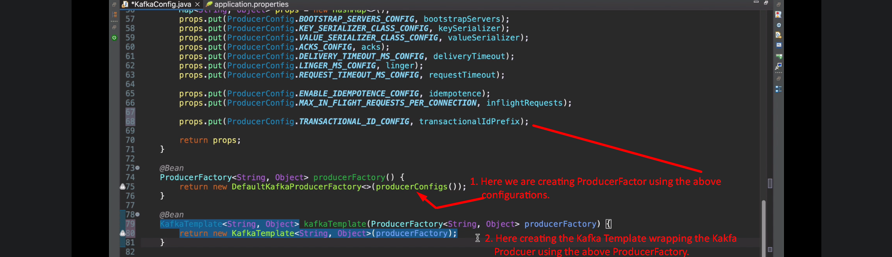
6. 